ALTAR FLOWERS
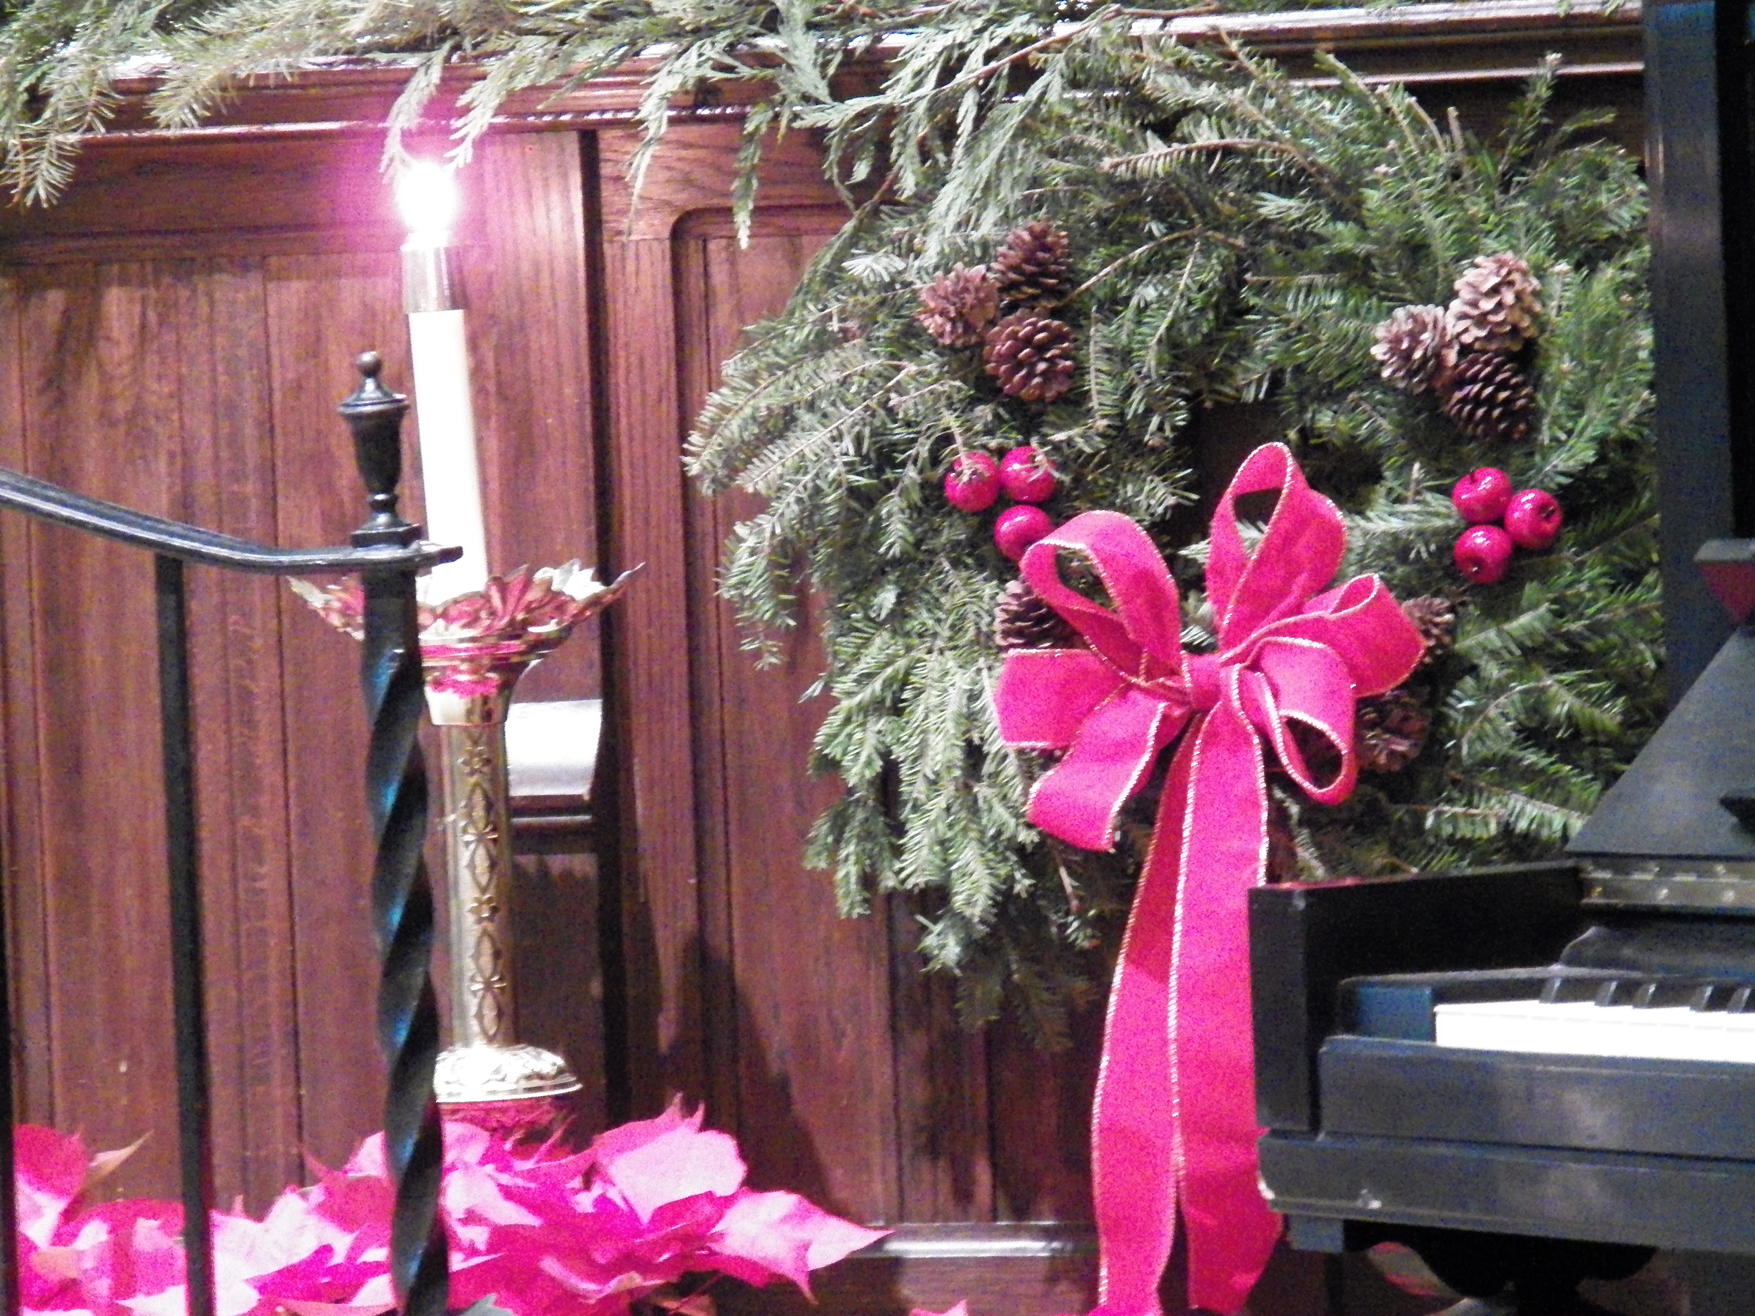
Each Sunday there are flowers on our altar. They are donated by parishioners or friends of the parish and given to the glory of God. They can be donated for any special occasion – in memory of a loved one, or for a thanksgiving, a birthday, anniversary, graduation etc. as well as for Easter or Christmas. The flowers are arranged each week by an altar guild team. Following the service flowers then go to the hospital or to homes of parishioners who cannot come to church.

If you would like to donate flowers please fill out and return the completed form (below) to the church office. A donation of $25 - made payable to: St. Mark’s Altar Guild - for each occasion is requested. Please include the name of the person or reason for the flowers and by whom they are donated.
Please feel free to call Sandy Dempsey at 860-860-828-6981 if you have any questions.
---------------------------------------------------------------------------------------------------------
ALTAR FLOWER FUND (Please print information)

Donated by: _____________________________________________

On the following date:
1. Christmas Memorial 2017 __________for Names: ___________________
________________________________________________________________________________________________________________________________
2. Special Day(s) (*Specify date and reason below.)
Date: _______________________
In loving memory of: (Names) __________________________________________
________________________________________________________________________________________________________________________________
Date: _______________________
In thanksgiving for (Names)____________________________________________
________________________________________________________________
Occasion: Please circle one: Birthday Anniversary Graduation Other___________________
Donations included: $ ________________
For Christmas Flower Donations: Please complete and return to St. Mark’s Church Office NO LATER THAN SUNDAY, December 17, 2017.
Additional copies of this form may be obtained by calling the church office at
860-225-7634. smec:committees & guilds/liturgical/flowers/Altar Flowers 2017.doc

